19.26: For an ideal gas, 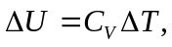 and at constant pressure, 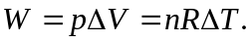
Using 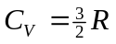for a monatomic gas, 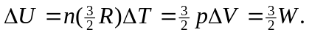 Then 